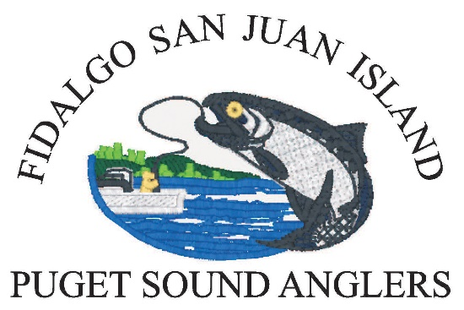

The Fidalgo San Juan Island Chapter, Puget Sound Anglers is offering scholarships to graduating high school students who best meet our criteria. We will be looking for a student wishing to pursue a degree in fisheries, environmental sciences, or a closely related field. Each year we award approximately $4500 in scholarships and grants. A Successful applicant may apply annually to renew the scholarship for a total of 4 years as long as they are in a fisheries or related program and maintain a C+ or better GPA. To receive full consideration each student that applies should provide the following:

- Letter of interest to include a brief narrative about themselves, their education plans, and their goals. May submit as a video presentation if so desire.

- A resume, may be traditional or a video essay

- High school transcript

- Letters of recommendation (no more than three)

All applicants must submit scholarship applications to:

Fidalgo – San Juan Islands Chapter, Puget Sound Anglers
P.O. BOX 647
Anacortes WA, 98221

All scholarship applications must be post marked no later than April 15th

For more information you may contact Alan R. Williams DVM at 360-202-8460, or mail at alanr_45@comcast.net

